WSCFFI Activities 2018
Kuni, just a start I can certainly add much more, decide what you would like to see changed>

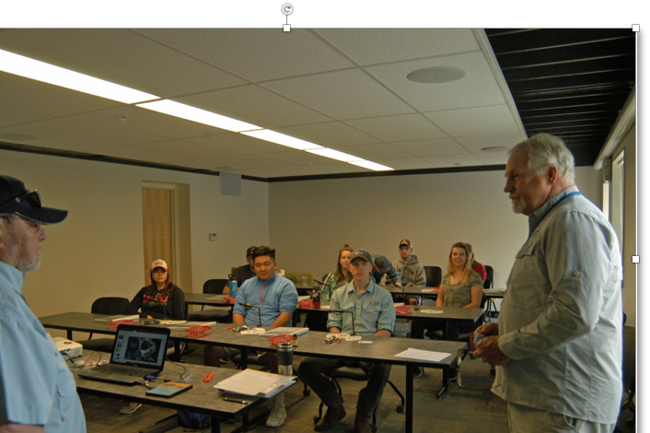 Mike Clancy and Aaron Cully of the Washington Council FFI in front of a class of beginning fly fishers from Central Washington University. Members of the university fishing club, learned the sport from casting to entomology during the Ellensburg fair.

Dominic Singh at work on a bass streamer that combines wool and craft fur on a Daiichi sproat hook.  Singh, who is 17, ties daily and has become a Nor-Vise Pro. He has one fishing companion his age. The others are older people who have the stamina to keep up with a teenager. | 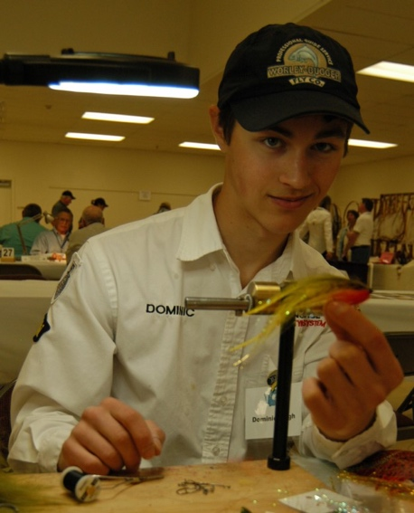

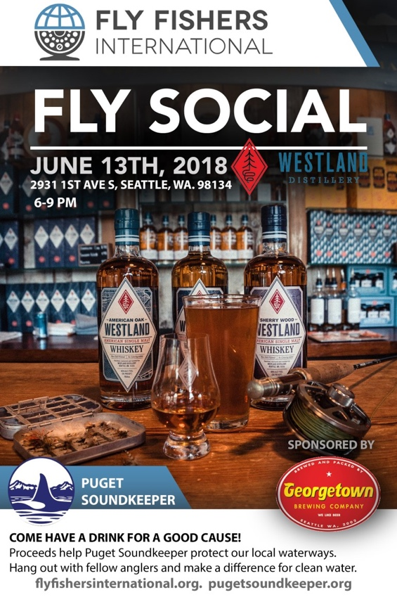 | Over the last couple of years, FFI leadership has been exploring a variety of ways to attract a younger and more diverse group fly anglers to our organization. Membership oriented organizations are generally indecline and we need to examine ways to more effectively  reach a more diverse demographic. Other organizations and a few clubs have  tackled this goal successfully and are doing a great job of attracting younger fly angler’s through more informal events. Clubs are finding success reaching new members through events such as brew ties, wine tastings, hackles and hops tying gatherings, and pint night events.

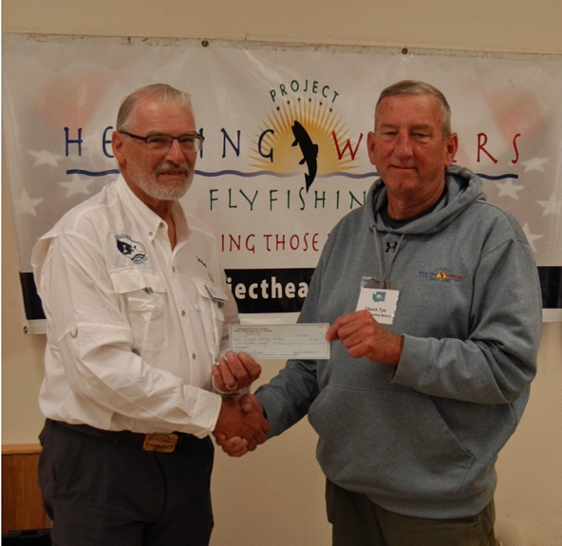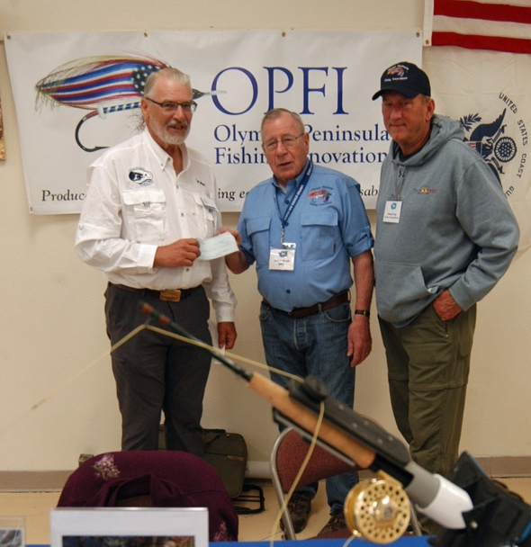
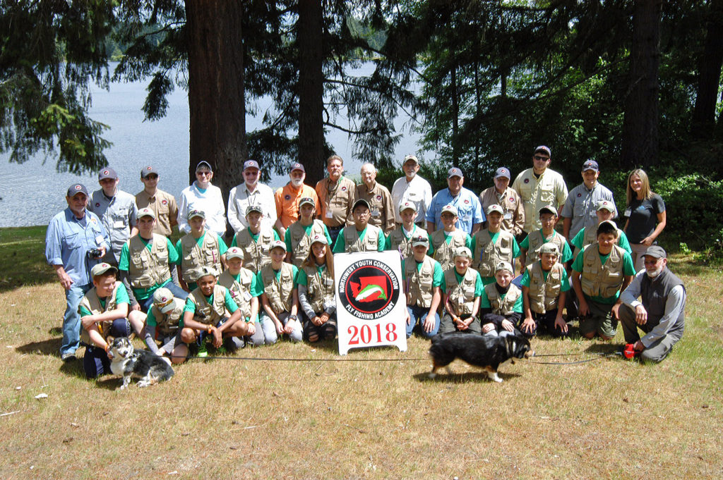Twenty-one enthusiastic boys and girl graduated from the 2018 NW Youth Conservation and Flyfishing Academy this past summer.
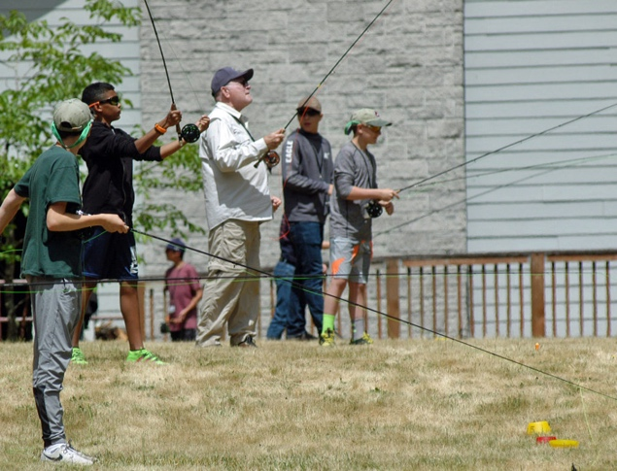
After a week of classroom study, classes in fly tying, knot tying, conservation, stream side ethics and etiquette, water safety, stillwater fly fishing techniques, matching the hatch, exploring a stream to learn about “Living Waters”, principals of ecology and disecting a fish, they were tired. A couple days we started at 5am to go to the ponds or rivers to learn how to fly fish. It’s not about catching, it’s about learning how to catch and how to read the waters, how to walk in a river, learn to mend. They fished both morning and evening
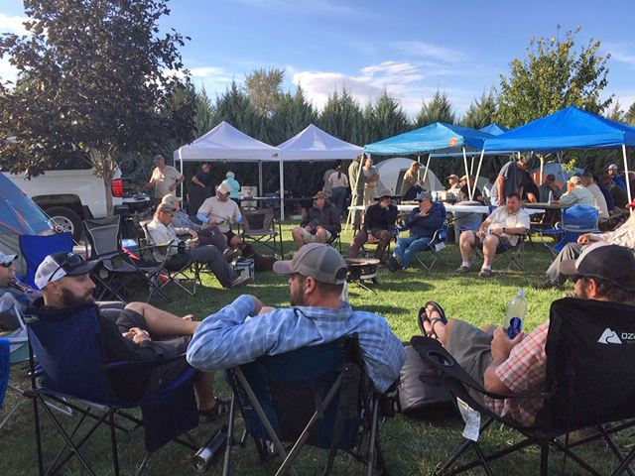 | 2018 Project Healing Waters Gets Veterans into Yakima Trout

Conservation…….. Not too Hot, Not too Cold | 